2017 Summer
Works Applications Recruiting Internship Mission

Mission Overview - “Design a management system for fast food chains”
You, as an engineer of the software package vendor, are in the process of designing an application software which can help your customers increase their profit.

In this project, the target of the product is a company which own fast food chains across the world such as MacDonald, KFC or Pizza Hut. They provide service for a variety of customers.
The main users are the area managers, in charge of a particular area with several stores. The product should support various kinds of users' tasks while giving consideration for the priorities.
What kind of daily work does your product control? When your product will be used? You can define your product by yourself.

Please carefully concern how the managers operate their chains and why they are willing to purchase your application.
The Aim of the Mission
Your vision and plan is the key to tackle the mission throughout your
Vision
Plan
Action
internship.
①Vision：
Visualize the ideal situation (Business/Work process hypothesis)
Picture an ideal flow of business that is smart and efficient without any hassle.
What kind of unrepeatable merits can your idea have?
②Plan:
Plan for the goal: catalog design
Create a plan to realize the goal/vision you have, making your vision to a reality.
③Action:
Act on the plan (Implementation)
With your own strength as a computer scientist, making your plan come true with your
programming skill, realizing the vision you have.

How to submit your work online
There are 3 mission files for you to work on:

- Business Process
Refer to the file-【Mission】Business Process
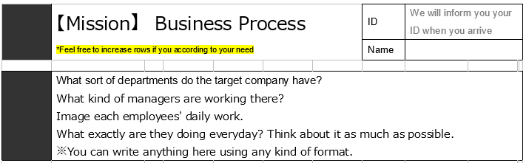
→ A sheet for you to freely imagine and write out what sort of work processes are there for the client.

- Business Analysis
Refer to the file-【Mission】 Business Analysis
→ Organize the contents of the work that you have imagined/investigated for your client; write down the overview, process, person-in-charge, place, of the work. A sheet for you to write out the “ideal state” “merits” “gap” “reason for gap” for each work process.
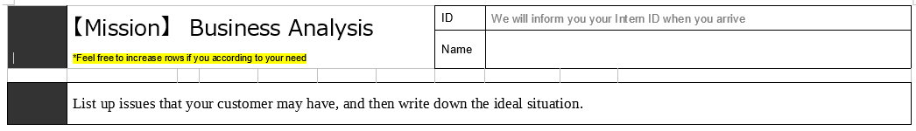
- “Catalog”（Proposal/Document） MOST IMPORTANT
Refer to the file-【Mission】Catalog
After all the hypothesis and analysis, consider the methods to realize the ideal and express it on a proposal/catalog (We call it a “catalog”). The client of you should be able to know ALL about your product by only reading this material.
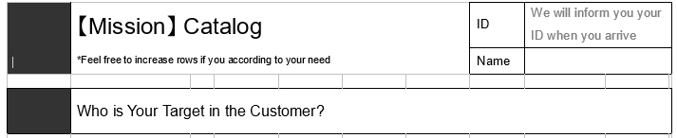

About the submission and Skype review
- Submission deadline: 2017/7/23 23:59.
- How to submit: Go to “My page” and find following page to update your documents.
1. Go to MyPage to open for the message with the following title and press “reply”
“〈IMPORTANT〉2017 Summer Internship Mission Release ”

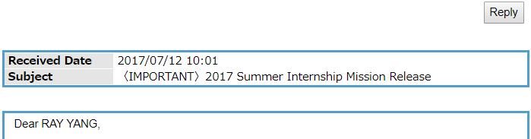

2. Reply to the message with your files attached
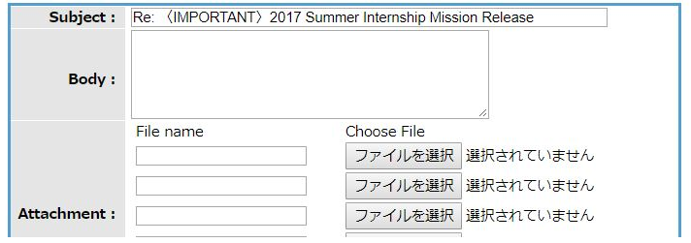
- What to submit ※Please write all document in English and export your file in pdf

【Mission】 Catalog (MOST IMPORTANT)
【Mission】 Business Process (A tool for you to help you think)
【Mission】 Business Analysis (A tool for you to help you think)

Naming Rule:
“YourFullName_Catalog.pdf” →e.g. ChenYiyang_Catalog.pdf
“YourFullName_BuisinessProcess.pdf” →e.g. ChenYiyang_BuisinessProcess.pdf
“YourFullName_CatalogAnalysis.pdf” →e.g. ChenYiyang_BuisinessAnalysis.pdf

- Skype review date: 2017/7/25
- Skype review time: Book through “My page” by yourself.
Reservation message will be sent to your “My page” before 2017/7/23
※Skype review is in ENGLISH.
After Your Skype Review
Please wait for the announcement of the result if you pass the review or not by message.
Make sure to put your best effort on the submission and review.

Reminder:
- Think deeply before designing your product. Please explain each feature and their benefits in your document.
- Put yourself in clients’ shoes. Think about why they need a system? Who are going to use it? Why your system is helpful? Would you spend your own money to purchase the application? How can the application increase profit using your system? Think deeply and logically.
- Please assume your reviewer to be your client, and you need to promote your product to them. Remember, convince them to pay for your idea and your work!

*If you have any question, feel free to contact: wap_global@s-hr.jp .

